Welcome!

New Cub

Scout Family

A Family Information Guide

**Council Website:**

[**www.bsacmc.org**](http://www.bsacmc.org)

**Like the Council Facebook Page:**

[**HTTPS:WWW.FACEBOOK.COM/BOYSCOUTSOFCENTRALMINNESOTA/**](HTTPS://WWW.FACEBOOK.COM/BOYSCOUTSOFCENTRALMINNESOTA/)

**Sign up for newsletters from Council:**

[**https://www.bsacmc.org/subscribe**](https://www.bsacmc.org/subscribe)

**Council Office: Watkins Service Center**

**1191 Scout Drive**

**Sartell, MN 56377**

**320-251-3930**

**Why Join Cub Scouting?**

• If you could give only one gift to the young people who are most important in your life, what would it be? No matter what your family situation is, it is within your power to help these children grow into people with a good feeling about themselves and a genuine concern for others. Cub Scouting can assist you in providing this greatest gift of all.

• Cub Scout-age children benefit developmentally from belonging to a small group of peers. Your child will be a part of a den, a small group of Cub Scouts in the same grade level. Through this sense of belonging, children build self-esteem and learn to get along with others.

• As a parent, you want to be assured that the groups that your child joins will teach values consistent with good citizenship, character development, personal fitness, and leadership. The values we seek to instill are found in the Scout Oath and Scout Law.

Scout Oath

A Scout is trustworthy, loyal, helpful, friendly, courteous, kind, obedient, cheerful, thrifty, brave, clean, and reverent.

Scout Law

On my honor I will do my best to do my duty to God and my country and to obey the Scout Law; to help other people at all times; to keep myself physically strong, mentally awake, and morally straight.

We know that kids do not join Cub Scouting for character building. Kids join because it is fun! Your child will learn great lessons, but they will be far too busy having fun to notice.

How Does Cub Scouting Work?

In Cub Scouting, you and your family join in on the program with your child, and you will help them along the way. Cub Scouts have a different handbook at each grade level, with **adventures** that are age-appropriate for their developmental level. As your child advances through these books by working on adventures, they will earn badges and other recognition that they wear on their uniform. As your child grows in Cub Scouting, your role will change with them, from hands-on involvement to guiding and coaching. Your child’s success in Cub Scouting depends on you!

The Cub Scouting program takes place at two levels. Your child will be a part of a **den**, a small group of Cub Scouts in the same grade level. A den typically meets twice a month, although some may meet more often. All dens, from kindergarten through fifth grade, make up a **pack**. Once a month, the dens, with their families, come together at the pack meeting and Cub Scouts are recognized for the adventures and badges they have earned.

New Cub Scout

Open House 2023

Saturday, September 30, 2023

10:00am to 1:00pm

Council Office-Watkins Service Center

1191 Scout Drive, Sartell MN

For any New Scout entering Kindergarten – 5th Grade

Lions Honor and Bobcat badge activities for Scout there will be BBgun, Archery, Camp information, other fun activities and games.

**FREE**

Registration Required

Sign up online at [www.bsacmc.org](http://www.bsacmc.org)

**Bonus:** You will be able to get all your Scout Supplies at the Scout Shop, such as, Uniforms, handbooks, neckerchiefs, slides and belts and much more.

**Questions:** Contact 320-251-3930



**Haunted Cub Prowl**

**Parker Scout Camp**

**21930 Paradise Dr., Nisswa, MN**

**Oct 28, 2023 10am – 3pm**

**Costume Contest, BB Guns, Archery, Games,**

**Crafts and much more.**

**Lion/Tiger/Wolf Event**

**Who:** Youth in Grades K-2nd Grades and their parent/guardian.

**What:** Swimming, BB Guns, Complete Adventure Loops/Pins, Patch, Snack, and lots of Fun.

**When:** November 4, 2023

**Where:** Foley High School

Register: [**www.bsacmc.org**](http://www.bsacmc.org)*(more details coming soon)*

**More information is coming soon.**

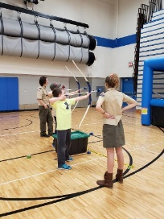

**Bear/Webelos Lock-In**

**Who:** Youth in Grades 3rd-5th grade and their Parents

**What:** Swimming, BB guns, Archery, lots of fun

**When:** April 6-7, 2024

**Where:** St. Cloud YMCA

**Register:** [www.bsacmc.org](http://www.bsacmc.org) (more details coming soon)

**More information is coming soon.**

**Dens**

**The Lion (Kindergarten) and Tiger (First Grade) Dens**

Cub Scouts who join in kindergarten or first grade join with an adult partner, usually the parent or guardian. A Lion or Tiger den should be no more than eight Cub Scouts and their adult partners. An adult is selected to serve as the den leader (usually one of the parents) and coordinates the meetings. Each adult partner takes a turn assisting or hosting meetings or activities with the den leader. This shared leadership model is a great way to ensure the den leader has the help needed to deliver a quality program.

Lion dens (kindergarten) meet once a month or more often if the den leader and families choose to.

Tiger dens (first grade) typically meet twice a month or more often if the den leader and families choose to.

At den meetings, Lions and Tigers work on adventures that are found in their handbooks.

**The Wolf (Second Grade) and Bear (Third Grade) Dens**

Children this age are becoming more independent, and activities are designed to meet their developmental needs.

A Wolf (second grade) or Bear (third grade) den is ideally no more than eight Cub Scouts, a den leader, an assistant den leader (usually parents of some of the den members), and often a den chief (an older Scout who helps the den leader).

They typically meet twice a month at a regularly scheduled time and place, and they also attend the pack meeting with their families.



**The Webelos Scout Den (Fourth and Fifth Grades)**

The Webelos den is much like the Wolf and Bear dens, but there is more emphasis on learning to take leadership roles and preparing to join a Scout troop.

**Pack Meetings**

**The Cub Scout pack is made up of all the dens, which meet monthly at the pack meeting, led by the Cubmaster. There are games, skits, songs, ceremonies, and presentations of achievements and badges that Cub Scouts earned during that month. This is where families can see the achievements of their Cub Scout.**

**The pack, including families, also participates in other special events throughout the year, including:**

* **Pinewood Derby®—You can build and race a model car with your child.**
* **Blue and gold banquet—Cub Scouting’s birthday party—for all pack members and their families— takes place in February.**
* **Camping—Overnight and day camp opportunities introduce your family to the camping experience.**
* **Service projects—Packs may participate in food drives, conservation projects, or other community activities.**
* **Field trips and special outings—Den outings are a great way to learn more about the people and places in your community.**

**Make memories with your child that will last a lifetime!**

**How Can You Help?**

The most important help that you, as a parent, can give your child is to work with them on their Cub Scouting adventures as they work toward their badge of rank. The Cub Scout handbook is full of age-appropriate activities; some of them you do together at home. Den meetings are designed for Cub Scouts to complete adventures that are required for them to earn their badge of rank. When you have completed a requirement at home, make sure your den leader is informed so that they can properly record it and your child can be recognized for their achievements. **Your role as a parent is the secret to a successful Cub Scouting program!**

The den and the pack rely on parent participation to run a successful program. Cub Scouting operates through volunteer leadership. Volunteer leaders are an example of Scouting’s principle of service to others. By volunteering in Scouting, you are also giving your child and family the gift of your time. What could be more valuable? You will have an opportunity to be a positive influence in their life and in the lives of their friends. Here are some of the ways you could volunteer:

**Den leader** - Uses the Den Leader Guide and den meeting plans to lead the den at den meetings. Attends the monthly pack committee meeting.

**Cubmaster** - Helps plan and carry out the pack program with the help of the pack committee. Emcees the monthly pack meeting and attends the pack committee meeting.

# The Pack Committee

Every Cub Scout parent or guardian is invited to become a member of the pack committee. Pack committee members perform administrative functions of the pack. The committee meets monthly and includes the responsibilities below.

**Committee chair -** Presides at all pack committee meetings. Helps recruit adult leaders and attends the monthly pack meeting and pack committee meeting.

**Advancement chair** - Maintains advancement records for the pack. Orders and obtains all badges and insignia. Attends the monthly pack meeting and pack committee meeting.

**New member coordinator** - Manages the transition of new Scouts into the pack and coordinates orientation for new Scouting families. Responsible for the marketing and recruiting initiatives of the pack as well as the growth and retention of the unit.

**Secretary** - Keeps records of the pack committee meetings and communicates with families about upcoming pack events and activities.

# Treasurer - Keeps all financial records for the pack, including the pack bank account, and gives a monthly financial report to the pack committee. Attends the monthly pack meeting and pack committee meeting.

# Training

# The Boy Scouts of America offers convenient training for parents who volunteer. As a new parent, you can learn all about Cub Scouting and how quality Scouting programs are built. Log on to [my.Scouting.org](https://my.scouting.org/) and create an account to gain access to all available training content. For more information about training at all levels of the program, go to <https://www.scouting.org/training/>.

# Youth Protection

Child abuse is a serious problem in our society, and unfortunately, it can occur anywhere, even in Scouting. Youth safety is of paramount importance to Scouting. For that reason, the BSA continues to create barriers to abuse beyond what have previously existed in Scouting.

The Boy Scouts of America places the greatest importance on providing the most secure environment possible for its youth members. To maintain such an environment, the BSA has developed numerous procedural and leadership selection policies and provides parents and leaders with multiple online and print resources for all Scouting programs.

**All leaders are required to complete Youth Protection training**. All parents are encouraged to take the training. To complete the training online, go to [my.Scouting.org](https://my.scouting.org/dashboard-legacy) and establish an account using the member number you receive when you register for BSA membership. If you take the training online before you obtain a member number, be sure to return to [my.Scouting.org](https://my.scouting.org/dashboard-legacy) and enter your number for training record credit. Your BSA local council also provides training on a regular basis if you cannot take it online.

Youth Protection training must be taken every two years. If a volunteer’s Youth Protection training expires the volunteer’s registration will be suspended. For more information about Youth Protection, please see BSA’s Youth Protection website at <https://www.scouting.org/training/youth-protection/>.

**Books:** Youth handbooks are the *Lion Handbook* (comes with the Lion kit), *Tiger Handbook, Wolf Handbook, Bear Handbook,* and *Webelos Handbook*. Adult leaders use one or more of the following resources: The *Cub Scout Leader Book, Lion Den Leader Guide* (comes with the Lion kit), *Tiger Den Leader Guide, Wolf Den Leader Guide, Bear Den Leader Guide,* and *Webelos Den Leader Guide*. See your local Scout shop or www.scoutshop.org for prices and a wealth of other reasonably priced resources. **Pack dues:** The amount varies by pack, depending on money-earning projects conducted by the pack to decrease the amount needed to run the pack program. **Uniform:** The uniform and its cost vary by program for both youth and adults. Uniforms may also be purchased at your local Scout shop. See www.scoutshop.org for details and current prices.

**Spending Time with Your Child: The Secret of Success!**

Come join the fun of Cub Scouting as a family … it’s fun! You’ll make new friends, too, as you work with the parents of your child’s new friends. No task is too difficult when you’re having fun as part of a team of Cub Scout parents, reinforcing each other’s efforts to help your children grow up to be good citizens.

**Roundtable Schedules (August – May)**

**This is open to all parents and leaders.**

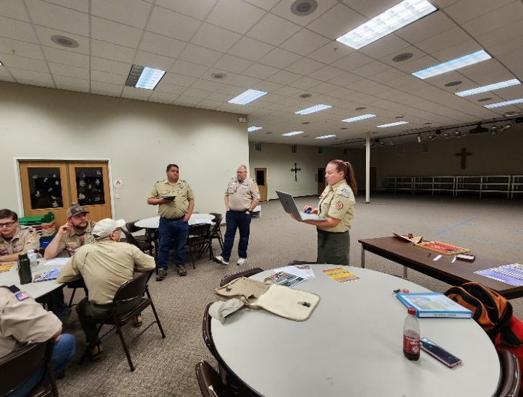

|  |  |
| --- | --- |
| **Gateway Roundtable:**  First Thursday of each month at  **Roundtable:** 7:00-8:30pm  [Trinity Crossing](https://www.google.com/maps/place/Trinity+Lutheran+Church/@45.5707813,-93.5820828,15z/data=!4m5!3m4!1s0x0:0x9146f2c06e7dc5bb!8m2!3d45.5707813!4d-93.5820828) in Princeton. | **Scenic Roundtable:**  First Tuesday of each month  **District Roundtable:** 7:00pm  [Council Office](https://www.google.com/maps/dir/45.5892251,-94.2173911/central+mn+council+bsa/@45.5911526,-94.22608,16z/data=!3m1!4b1!4m9!4m8!1m1!4e1!1m5!1m1!1s0x52b45e9c11732075:0x9aa18bd41b6b48b!2m2!1d-94.2248071!2d45.5919182) in Sartell, MN.  Scout shop will stay open until 7pm on Roundtable nights for Scenic District only |
| **North Star Roundtable:**  Second Thursday of Each Month  **Roundtable:** 7:00 PM  [Immanuel Lutheran Church in Wadena](http://www.wadenaimmanuel.org/)  403 2nd St SE, Wadena | **Pine Tree Roundtable**  First Tuesday of Each Month  **Roundtable:** 6:30 PM  [Salvation Army](https://www.google.com/maps/dir/45.5892251,-94.2173911/salvation+army+brainerd+mn/@45.9699182,-94.8506691,9z/data=!3m1!4b1!4m9!4m8!1m1!4e1!1m5!1m1!1s0x52b6bc04b1826109:0x555c01d158c9b8e8!2m2!1d-94.2024899!2d46.3566529)  Front and 5th Street, Brainerd |

**Cub Scout Events**

**Event Location Date**

**2nd Show & Sell Orders Due Online September 11, 2023**

**Join Scouting Night TBD September 21, 2023**

**2nd Show & Sell Order Pickup Various Locations September 26, 2023**

**New Cub Scout/Lion Day Council Office September 30, 2023**

**Webelos Activity Weekend Parker Scout Camp October 6-8, 2023**

**Show & Sell Returns due Council Office October 25, 2023**

**Haunted Cub Prowl Parker Scout Camp October 28, 2023**

**Popcorn Orders Due Council Office October 30, 2023**

**Lion/Tiger/Wolf Event Foley November 4, 2023**

**Popcorn Pickup Various Pickup Locations November 16, 2023**

**Nanuq Parker Scout Camp January 13-14, 2024**

**Nanuq Parker Scout Camp January 27-28, 2024**

**Scout Sunday Local Church February 4, 2024**

**Nanuq Parker Scout Camp February 10-11, 2024**

**District Pinewood Derby TBD March 16, 2024**

**Bunny Hop Parker Scout Camp March 23, 2024**

**Bear/Webelos Lock-In St. Cloud YMCA April 6-7, 2024**

**Basic Outdoor Leader Training Parker Scout Camp May 10-11, 2024**

**Cub Camp #1 Parker Scout Camp June 14-16, 2024**

**Cub Camp #2 Parker Scout Camp June 21- 2024**

**Cub Camp #3 Parker Scout Camp July 12-13, 2024**

**Popcorn Kick Off Council office & Parker July 28, 2024**

**1st Show & Sell Orders Due Online August 5, 2024**

**Family Camp Parker Scout Camp August 9-11, 2024**

**1st Show & Sell Order Pickup Various Location August 20, 2024**

**2nd Show & Sell Orders Due Online September 9, 2024**

**Join Scouting Night Various Locations September 19, 2024**

**2nd Show & Sell Order Pickup Various Locations September 24, 2024**

**New Cub Scout/Lion Day Council Office September 28, 2024**

**Webelos Activity Weekend Parker Scout Camp October 4-5, 2024**

**Show & Sell Returns due Council Office October 23, 2024**

**Haunted Cub Prowl Parker Scout Camp October 26, 2024**

**Popcorn Orders Due Council Office October 30, 2024**

**Popcorn Pickup Various Pickup Locations November 21, 2024**

**\*\*\*All Events and locations are subject to change\*\*\***

**Check our website for the most updated information:** [**www.bsacmc.org**](http://www.bsacmc.org)

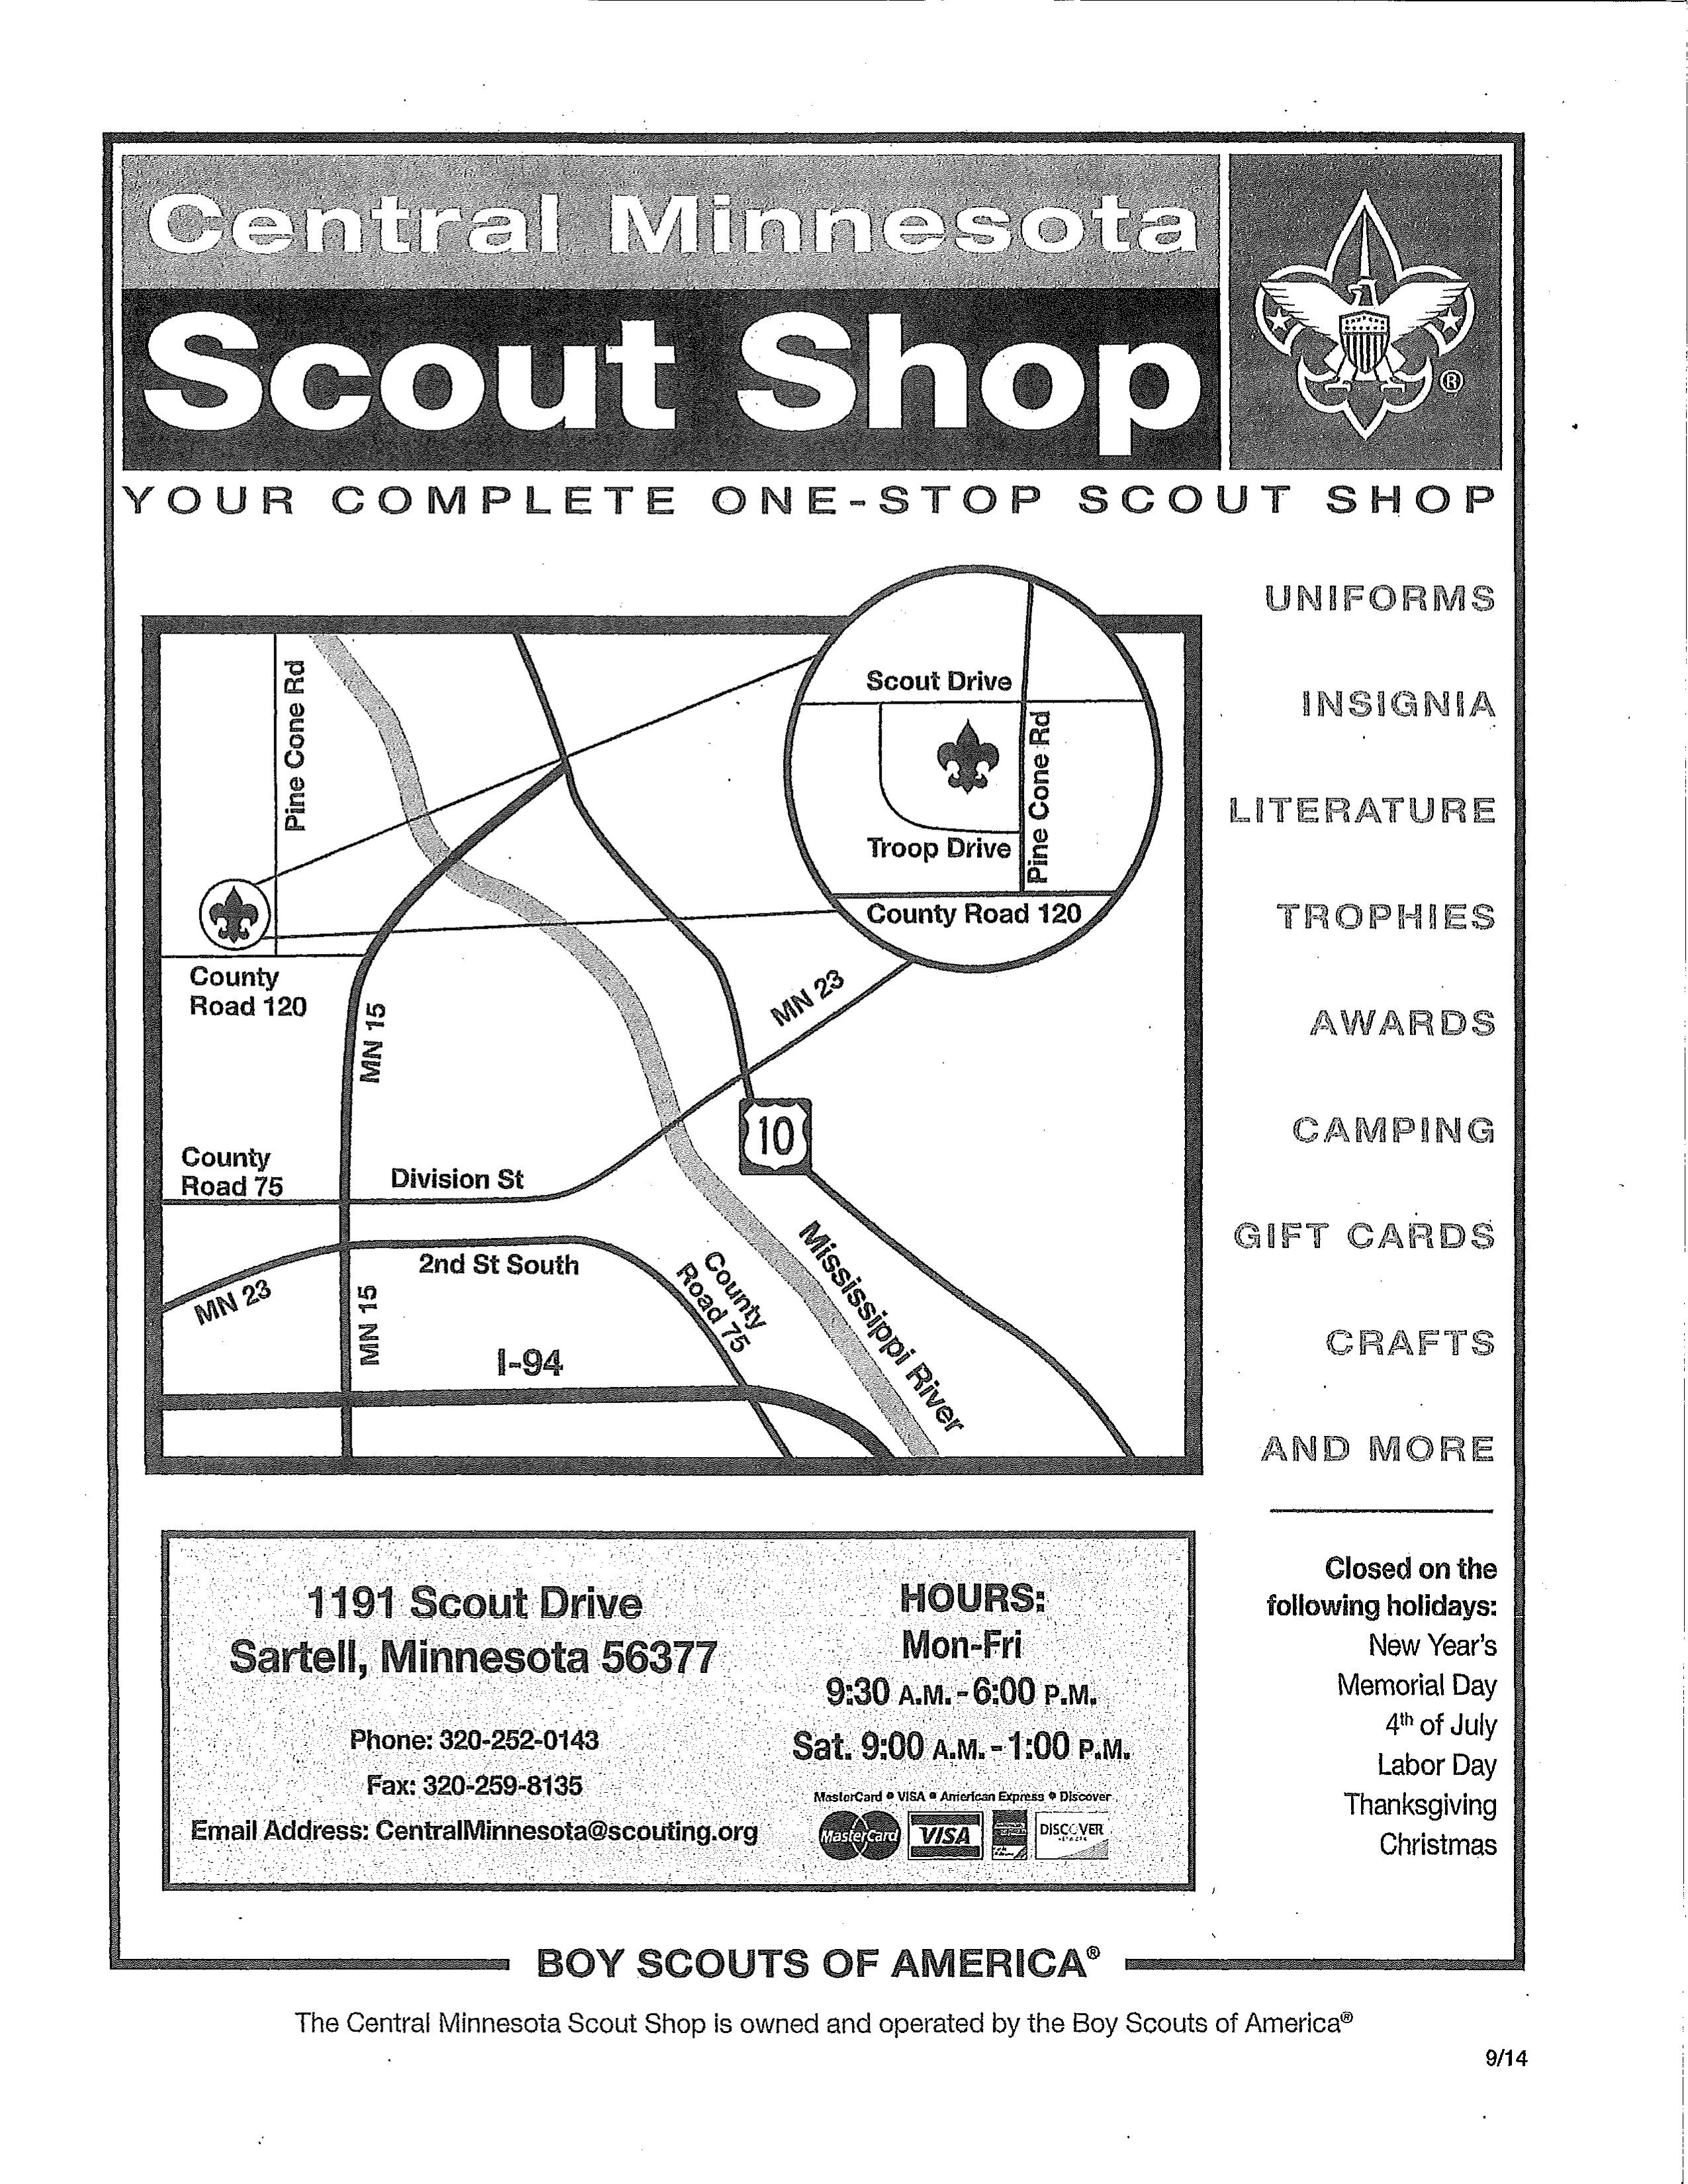

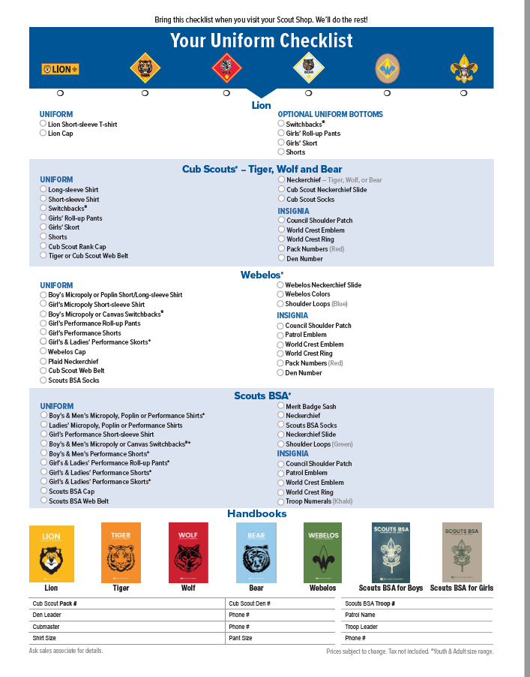

# NOTES