The Vigil Honor

The Vigil Honor is the highest honor that the Order of the Arrow can present its members for service to the lodge and/or council. It dates back to the year 1915, when OA's founder, E. Urner Goodman, became the first Vigil Honor member. Since then, thousands of members have been given this honor.

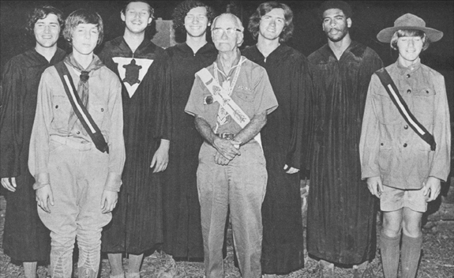

Reenactment of the original First Degree Ritual with founder Dr. Goodman.
60th Anniversary Celebration, Treasure Island SR, July 19, 1975
A Pictorial History of Unami Lodge One and Information for its Members, 5th ed.,
Jeffrey A. Aster, editor, p. 25 Copyright © 1990, Philadelphia Council, BSA

It is a high mark of distinction and recognition reserved for those Arrowmen who have given exceptional service, helping others beyond the call of duty involving personal effort and unselfish interest to one or more of the following: their lodge, the Order of the Arrow, their Council, Scouting, or their Scout camp. So, service in any of those areas would qualify a member for consideration. Under no circumstances should tenure in Scouting or the Order of the Arrow be considered as ample reason for a Vigil Honor recommendation.
Alertness to the needs of others is the mark of the Vigil Honor. This calls for an unusual awareness of the possibilities within each situation. Vigil Honor members have a time-honored tradition to uphold. As leaders, they must conduct themselves in accordance with the ideals of Scouting and the Order of the Arrow.

Once an Arrowman has been Brotherhood for at least 2 years he or she may be considered for the Vigil honor by the Lodge members. Generally, only 2% of the Arrowmen in a Lodge will achieve Vigil in any year – simply put, one Vigil for every fifty members or part thereof.

The National Order of the Arrow Committee has stated it best that: "The Vigil Honor is a high mark of distinction and recognition reserved for those Arrowmen who, by reason of exceptional service, personal effort, and unselfish interest, have made distinguished contributions beyond immediate responsibilities of their position or office to one or more of the following: their lodge, the Order of the Arrow, Scouting, or their Council Scout Camp."
While Brotherhood is a membership level you choose for yourself, the Vigil Honor is different. It is not appropriate to nominate yourself or a family member or ask others to nominate you. Doing so could adversely affect your consideration and selection. Others will nominate you by virtue of observing you and your hard work and service to the Lodge and Scouting. It’s an honor that only can be bestowed upon you.
Last year’s Vigil inductees were:

Nicholas Kosloske
Dane Vos
DJ Collins
Lonnie Murray

Vigil Honor can be recognized on the sash by the triangle located in the middle of the arrow.

This winter a list of eligible Brotherhood members will be sent to all of the Lodge members to consider for nomination of the Vigil Honor. It will not happen unless YOU, yes YOU, take the initiative of filling out a nomination form. Deadline for this is before the spring conclave. Nomination forms are available on the Naguonabe Lodge page on the council’s web site.

WHO WILL YOU NOMINATE IN THE SPRING?

Vigil Deadlines

January 2023 vigil eligible list approved
January 2023 vigil nominations open
May 18, 2023 deadline for nominations
May 19, 2023 vigil selections made
September 9, 2023 vigil conclave, Parker

