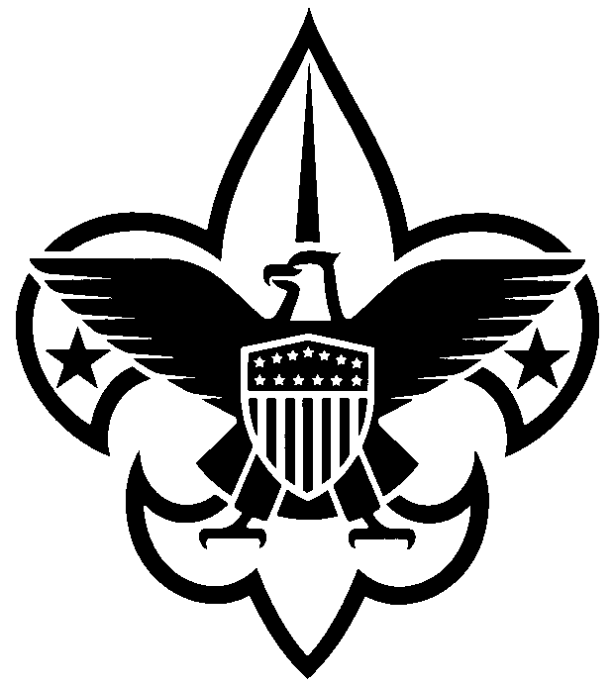
Annual District Registration Form
(January 1, 2024 – December 31, 2024)
Dear Scouter:
Your annual registration as a district volunteer is due. Please complete the form below and return to the Scout office with the appropriate fee. If you are currently registered primarily in the district or as a multiple with a unit, no adult application is required. If you wait to complete this process until after December 31, 2023, an adult application must be completed.

Name ______________________________________________ Date of Birth _______________

Address ______________________________________________________________________

City ____________________________________ State __________ Zip Code ______________

Home Phone ____________________________ Work Phone ____________________________

Cell Phone __________________________________________________________________

E-mail ________________________________________________________________________

District (Circle ONE): Gateway North Star Pine Tree Scenic

District committee position(s) _____________________________________________________

*Required Youth Protection Training Date Completed: _____________________________

Enclosed:

_____ $60.00 annual registration fee (An adult application must be submitted if you are
new to the district staff.)

_____ $12.00 Insurance Surcharge

_____ $15.00 Boys’ Life subscription (optional)

_____ $0.00 (My primary registration is at the unit level
(Circle ONE: pack troop crew team) #________- also serving on district staff.)

_____ Total enclosed (payable to CMC BSA)

___________________________________ ___________________________________

YOUR Signature District Executive Signature

Mail to: Central Minnesota Council, BSA 1191 Scout Drive Sartell, MN 56377

