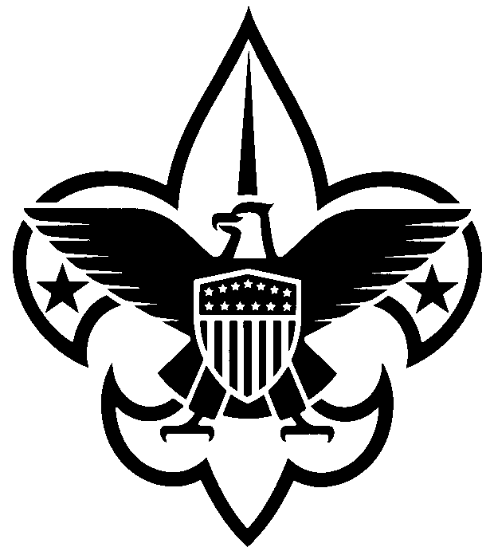

Annual Council Registration Form
(January 1, 2023 – December 31, 2023)

Dear Scouter: Your annual registration as a council volunteer is due. Please complete the form below and return to the Scout office with the appropriate fee. If you are currently registered as a primary in the council or as a multiple with a district/unit, no adult application is required. If you wait to complete this process until December 31, 2021, an adult application must be completed.

Name ______________________________________________ Date of Birth _______________

Address ______________________________________________________________________

City ____________________________________ State __________ Zip Code ______________

Home Phone ____________________________ Work Phone ____________________________

Cell Phone ____________________________________________________________________

E-mail ________________________________________________________________________

District _______________________________________________________________________

Council position(s) ______________________________________________________________

*Required Youth Protection Training Date Completed: ______________________________

Enclosed:

_____ $45.00 annual registration fee (An adult application must be submitted if you are
new to the council staff.)

_____ $12.00 Insurance Surcharge

_____ $15.00 Boys’ Life subscription (optional)

_____ $0.00 (My primary registration is at the unit/district level ______________ also
serving on council staff.)

_____ Total enclosed

___________________________________ ___________________________________

Scout Executive’s Signature Council Committee Member’s Signature
Mail to:
Central Minnesota Council, BSA
1191 Scout Drive
Sartell, MN 56377

