Central Minnesota Council, BSA ● Climbing Instructor Course
Friday, June 23, through Sunday, June 25, 2023
8am-5pm each day

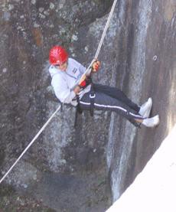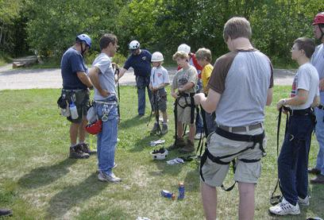

Come join us at Quarry Park in Waite Park.

Do NOT wear loose or baggy clothing – dress for any weather.

The course is open to any Scout adult leaders and Venture crew members 18 and older. Scouts/Crew members 16 and older may attend if they are accompanied by a parent or troop leader. This is a 3-day course so if you are from out of the area, plan to arrive on Thursday evening. You MUST attend all sessions or get the approval of Chuck Rose beforehand.

The course will cover climbing gear use and maintenance, site selection, risk management, climbing safety, anchoring, climbing techniques, rappel protocol, and more. This course will offer students plenty of hands-on training and climbing experience. Individuals who satisfactorily demonstrate their instructional, management and anchoring skills will be issued a Level 1 BSA Climbing Instructor Certification [good for 1 year]. If coming from out of the area, contact Chuck about accommodations.

Registration fee: $60 for new students or $30 for youth ages 16 and 17 or $25 for recertification. Due by June 19, 2023. (Payable to CMC BSA). Cost of the course includes all course materials and gear (not food).

This course is limited to 15 students.

Register at: https://scoutingevent.com/296-Climb23

Everyone must provide a BSA health form available at www.bsacmc.org . Indicate special dietary and accessibility needs on the Health Form. Youth participants (under age 18) must include a parent-signed consent on the medical form part C.

For more information contact: Chuck Rose, Course Director at 320-293-3332 or clrose@stcloudstate.edu

