Climbing Merit Badge Day

When: Saturday, June 25, 2023 – Merit Badge Day
Where: QUARRY PARK
1802 County Road 137, Waite Park, MN
Quarry Park charges $10 parking fee, come in groups if possible.

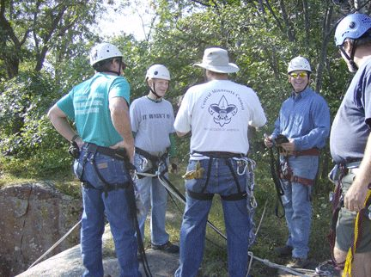 | 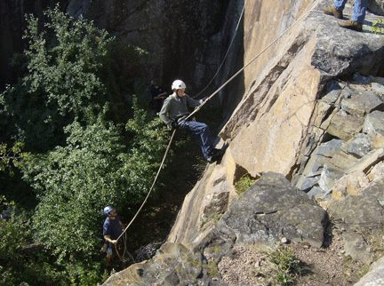 | 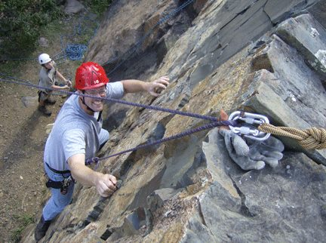

Who: Open to youth age 12 and older. No prior experience necessary.
Registration:
- Register online at: https://scoutingevent.com/296-Climb23
- $25/ participant attends Merit Badge Day. All climbing gear is included in the fee.
- MAXIMUM of 15 participants.
- Registration due by June 19, 2023.
- check in at 9:30 am in the parking lot with session from 10 am to 5 pm.
- AT LEAST ONE ADULT IS REQUIRED FROM THE UNIT TO BE WITH THE YOUTH

What to Bring:
- Climbing Merit Badge Pamphlet
- Annual health forms. Include any accessibility needs or special health needs.
- Youth participants must include a parent-signed consent part of the medical form.
- Wear comfortable “moveable” but NOT loose or baggy clothing.
- Rain gear, bug spray, sunscreen, etc.
- A bag lunch.
For more information contact: Chuck Rose, Course Director at 320-293-3332 or clrose@stcloudstate.edu

