THANK YOU!
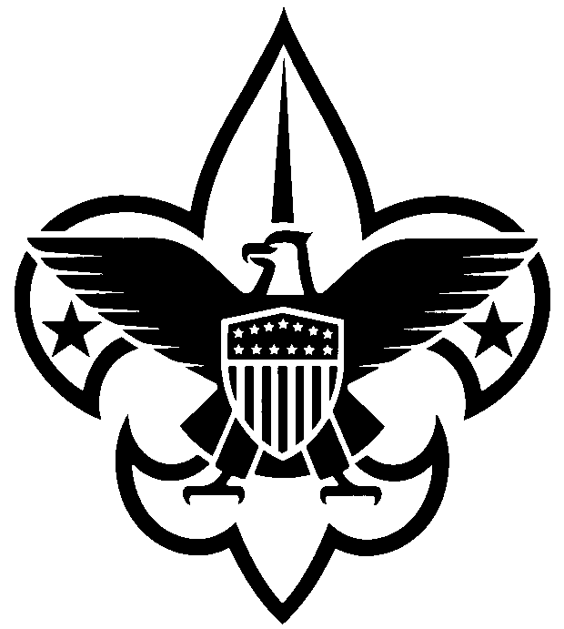

Dear ____________________________,

Thank you for your purchase and for supporting the Central Minnesota Council, Boy Scouts of America! Your donation directly helps me create lifelong memories. Through adventures such as camping, hiking and fishing, I learn to be a self-reliant and resourceful leader while building character and courage.
I appreciate your support!

__________________________________
Scout Unit

THANK YOU!

Dear ____________________________,

Thank you for your purchase and for supporting the Central Minnesota Council, Boy Scouts of America! Your donation directly helps me create lifelong memories. Through adventures such as camping, hiking and fishing, I learn to be a self-reliant and resourceful leader while building character and courage.
I appreciate your support!

__________________________________
Scout Unit
THANK YOU!

Dear ____________________________,

Thank you for your purchase and for supporting the Central Minnesota Council, Boy Scouts of America! Your donation directly helps me create lifelong memories. Through adventures such as camping, hiking and fishing, I learn to be a self-reliant and resourceful leader while building character and courage.
I appreciate your support!

__________________________________
Scout Unit

THANK YOU!

Dear ____________________________,

Thank you for your purchase and for supporting the Central Minnesota Council, Boy Scouts of America! Your donation directly helps me create lifelong memories. Through adventures such as camping, hiking and fishing, I learn to be a self-reliant and resourceful leader while building character and courage.
I appreciate your support!

__________________________________
Scout Unit
THANK YOU!

Dear ____________________________,

Thank you for your purchase and for supporting the Central Minnesota Council, Boy Scouts of America! Your donation directly helps me create lifelong memories. Through adventures such as camping, hiking and fishing, I learn to be a self-reliant and resourceful leader while building character and courage.
I appreciate your support!

__________________________________
Scout Unit

THANK YOU!

Dear ____________________________,

Thank you for your purchase and for supporting the Central Minnesota Council, Boy Scouts of America! Your donation directly helps me create lifelong memories. Through adventures such as camping, hiking and fishing, I learn to be a self-reliant and resourceful leader while building character and courage.
I appreciate your support!

__________________________________
Scout Unit

