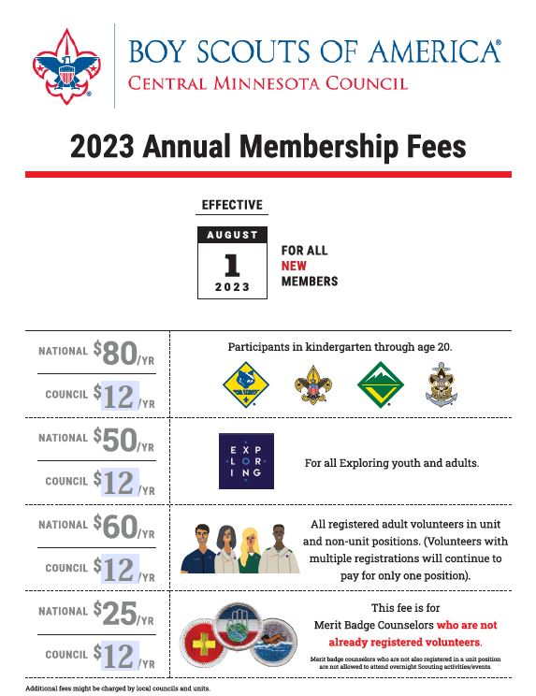
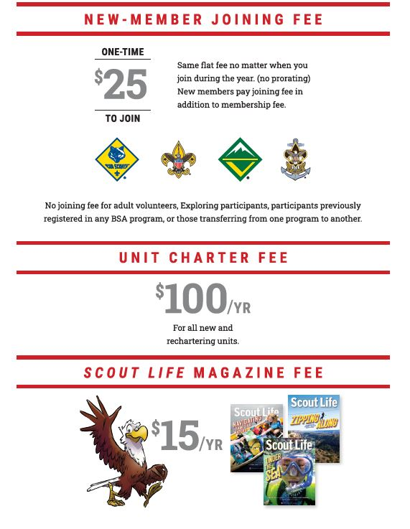

Existing scout  With council fee | New Scout  With new scout fee and council fee | Scout Life  Magazine | Adult  With council fee | Merit Badge Counselor  Not registered in unit  With council fee | Unit annual recharter fee
$92.00/year | $117.00/year | $15.00/year | $72.00/year | $37.00/year | $100.00/year

