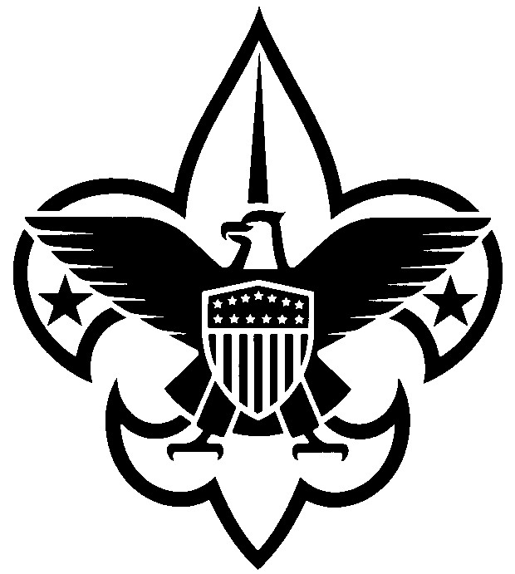
Annual Council Registration Form
(January 1, 2024 – December 31, 2024)

Dear Scouter: Your annual registration as a council volunteer is due. Please complete the form below and return to the Scout office with the appropriate fee. If you are currently registered as a primary in the council or as a multiple with a district/unit, no adult application is required.
If you wait to complete this process until Feb 28, 2024, an adult application must be completed.

Name _________________ Date of Birth _________________

Address ______________________________________

City _________________ State _____ Zip Code __________

Home Phone _________________ Work Phone _________________

Cell Phone _________________

E-mail _________________

District If Applicable

Council position(s) _________________

*Required Youth Protection Training Date Completed: _________________

Enclosed:

☐ $72.00 annual registration fee (An adult application must be submitted if you are new to the council staff/Board. $60.00 National Fee + $12 Council Fee)

☐ $15.00 Scout Life subscription (optional)

☐ $0.00 (My primary registration is at the unit/district level Enter unit # or District
Also serving on council staff.)

_____ Total enclosed

__________________ ___________________________________
Signature Scout Executives Signature
Mail to:
Central Minnesota Council, BSA
1191 Scout Drive
Sartell, MN 56377

