Central Minnesota Council, Boy Scouts of America
1911 Scout Drive, Sartell, MN 56377
(320) 251-3930
Request for use of Scout Office Facility
(Please sign and return a copy to the Scout office at least thirty days prior to date requested)

Name of Organization: ________________________________________________________________

Address, City, State, Zip _______________________________________________________________

Email ______________________________________________________________________________

Date Requested: _________________________________ Time Requested: __ ___ _________

Room(s) Requested: ☐ Large Community Room ☐ Medium Conference Room
Expected Attendance: _____________________________________________

State the general purpose of meeting and brief description of program:
_________________________________________________________________________________________

☐ Large Community Room (dimensions 40’ x 58’ – 2300 sq feet) - 150 available chairs, accommodates 148 dinner seating)
1-3 hours 3+ hours
Half Room (recommended for 1-40 people) $100 ☐ $175 ☐
Full Room (recommended for 45+ people) $150 ☐ $250 ☐
Sub Total $ ___________
☐ Medium Conference Room - $50 alone, however, no charge if renting large community room $ ______________

Type of Tables:
☐ 60” Round tables #_____________ (13 available)
☐ 6 Foot tables #_____________ (6 available)
☐ 8 Foot tables # _____________ (13 available)
- Rentor is responsible for setting up of tables and chairs

AV Equipment Requested:
Power Point Projector @ $50 $ _____________
Easel & Pad @ $15 $ _____________
Copies @ $.10/each $ _____________

Sub Total: $ _____________

Total Remitted: $ _____________

I understand that if there is any damage to the carpet there will be a minimum of $50 charge for cleaning and/or replacement. (No Red/Purple or Orange Kool-Aid allowed in Community Room.)
Please return with a check payable to CMC/BSA or to pay via credit card call 320.251.3930.

Signed __________________________________________________

Phone ______________________________ Date ______________
Community Room – Available for Rent
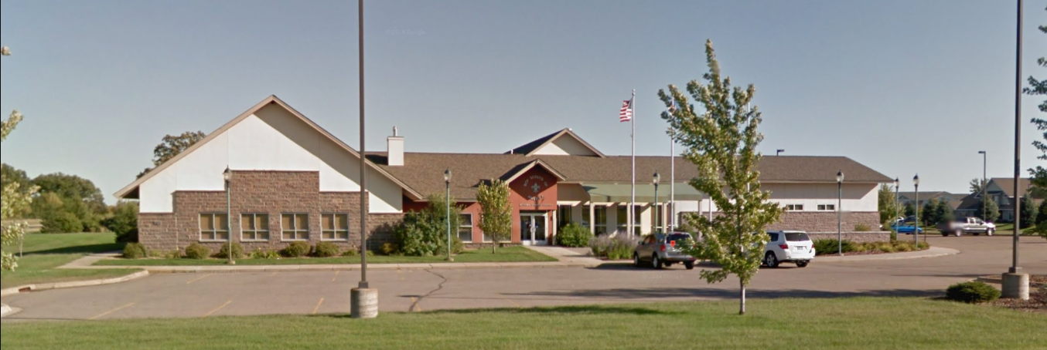

- 72 parking spaces
- Easily accessible off of Pinecone Rd.
- Large spacious lobby with close by restroom facilities

