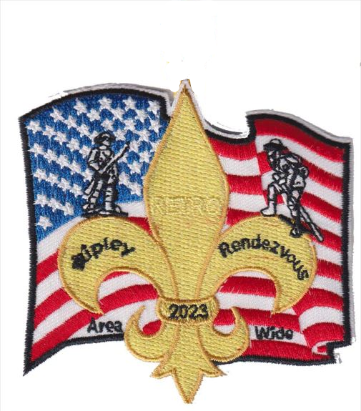
2023 Ripley Rendezvous

June 1st - 4th
^{Unit Leaders Guide}
Like us on Facebook at Ripley Rendezvous
It is the vision of the 2023 Ripley Rendezvous event to provide scouts and leaders with a safe and unique outdoor experience that engages, challenges and thrills all that attend.
It is our Mission that everyone will discover the hands-on excitement of learning, and exploring, while building the confidence to meet those challenges.

Table of Contents
Registration 3
Check In 3
Motor Vehicles / Parking / Pedestrians 4
Health and Safety 4
Emergency Phone Numbers 4
Reporting Incidents in Camp 4
Youth Protection Policy 5
Accommodations 5
Camp Information 5
Restrooms 5
Unit & Personal Equipment 6
Unit Equipment 6
Personal Gear 6
Optional Personal Items 7
Program Descriptions 7
Action Centers 7
Adventure Program 7
Extreme Program 7
Military Museum 7
Saturday Evening 7
Sunday 7
Check out 7
Lost and Found 8
Policy on Smoking, Alcohol, Drugs and Weapons 8
EXPLOSIVES & AMMUNITION 8
Participating Area Councils 9
Tentative Schedule 10
Cantonment Map 11
Emergency Phone Numbers 11
Refund Policy…………………………………………………………………………………………………………………………………………………… 12

Registration
- Must provide A/B Health for all scouts and adults.
- All Youth must have shooting sports waivers. (No Waivers no shooting sports participation)
- All participants attending zipline must have filled out and signed waivers. (No Waiver No Participation)
- The Adventure and Extreme programs will be down range for half the day so come prepared.
- Registrations will be confirmed with camp areas and program choices.
- There will be a small online service fee charged to each registration.
- If you have not received confirmation within 10 days of the event, please contact the Central Minnesota Council, BSA office at 320-251-3930.
- Refund Policy (see page 12).

Check In
- Those units arriving Thursday and attending programs on Friday- Check in will start at 5pm Thursday. There will be a special zoom meeting at 6:00pm on Sunday May 21, only those units.
  - For those doing Ziplining they will need a Waiver signed by their parents
- You will receive special instructions for check-in within the week after the event registration closes on May 22nd. If you haven’t seen anything, please contact our office at 320-251-3930.
- Check-in is from 5 p.m. to 11 p.m., Friday June 2 , welcome letter will specify procedures. Only two people from your unit will need to come to check-in. (Rec Center Bldg. 6-97)
- The 2023 Ripley Rendezvous is designed for Scouts BSA members, Ventures’, and Explorers. Boys and Girls who are currently Webelos in the 5th grade and who have transitioned into the Scout Troop as of June 2nd, 2023, are able to participate as Scouts for this event and should register through a Troop. No Cub Scouts may participate in this event!
- NO HEALTH FORMS or NO SIGNATURE = N0 PARTICIPATION
- NO SHOOTING SPORTS Waivers = NO Shooting (archery, rifles, paintball, etc.)
  - All Scouts must bring a copy to participate in any shooting sports activity.
- Adult Leadership: It is mandatory that all units have two-deep leadership, per BSA guidelines. 1 to 5 ratios of leaders to youth is recommended.
- Be patient when you arrive at the gate and while you are waiting to check in. Camp Ripley will be doing their best to ensure that the post remains secure during our check in process and during the weekend events. It’s a big deal, be sure to remain respectful and patient.
- Be sure all adults that are driving bring a valid drivers’ license to pass Camp Ripley Gate-it’s required. All adults must have a valid ID, it will be checked at the gate against our Roster by Camp Ripley Staff (required).
- Put your colored parking pass in the window of each vehicle before entering Camp Ripley.
- Drivers are forbidden to use cell phones while driving- this is a Camp Ripley Post Policy and could result in a fine.
- There should be no smoking within sight of Scouts during the weekend and dispose of properly!
- It is required that all registered adults from each unit be Youth Protection Trained.
- Be sure to bring 2 copies of the health form, parts A and B, for each person in attendance from your unit. You will turn a set into the check in area and you should have a set for your unit as well. You will get the health forms back at check out when you receive your event patches.
- Scouts are guests of the Minnesota National Guard & Camp Ripley. We (the Scouts) are not their primary focus during our stay on post. The Minnesota National Guard will do their best to display, demonstrate, and include us in the cool things they have available.

Motor Vehicles / Parking / Pedestrians
- Trailers may be dropped off in the campsite, no cars/trucks/vehicles can remain at the campsite
- Do not block roadways or sidewalks when parking
- Never ride in the bed of a truck
- Speed limits must be obeyed
- No skateboards, inline skates, bikes, scooters or 4 wheelers
- Stay off the roadway except to cross at designated areas
- Walk facing traffic
- Carry a flashlight at night
- Give Emergency vehicles the right-of-way
- Stay in your designated scouting areas

Health and Safety
Emergency Medical, Please DO NOT use 911!

Emergency Phone Numbers
- Headquarters Building 3-1 call: 320-616-7221
- A staffed 24-hour First Aid station will be available at Building 3-1 call: 320-616-7222
- There will be first aid stations in all program areas
- On-site EMT and security personnel provided
Camp Ripley Emergency #
Camping Area Emergency 320-632-7375
Range Emergency 320-616-3137
Ripley Rendezvous leadership, Security numbers, plus opt-in text messaging capabilities will be included in check in packet.

Reporting Incidents in Camp
In case of an emergency, such as Fire, bodily injury, or lost person, report to the Event Headquarters in Building 3-1 call: 320-616-7221
- Completed Health Forms Part A and B, for everyone, must be presented turned in at check-in (downloadable at BSACMC.org)
- Each unit is responsible for providing a first aid kit at their camp site
- Distribution of medicines is the responsibility of the unit leadership. (Follow the Guide to Safe Scouting: XI Medical Information – under Prescriptions.)
- If you have an adult or youth with any physical or behavioral conditions that limit participation, please notify the Central Minnesota Council at 320-251-3930 to make the appropriate accommodations.
- NO HEALTH FORM or NO SIGNATURE = N0 PARTICIPATION

Youth Protection Policy
All youth Protection Policies of the Boy Scouts of America will be followed during this event. Any incidents should be reported immediately to your Council’s Scout Executive or if unavailable, contact headquarters at building 3-1 to receive instructions and support.

Accommodations
- The 2023 Ripley Rendezvous is a Jamboree style camp out.
- Every troop will be assigned to a camp area and will be directed at arrival.
- Unit Trailers will be allowed in the camp sites. However, camping space and parking is limited, be sure to bring only the vehicles you need, the tents and gear that your unit will need. Only the vehicle pulling the trailer will be allowed into the site to drop off the trailer. Then those vehicles need to park in Parking area. No vehicles can be left in camping area. NO EXCEPTIONS. Traffic will be routed using “one way” routes this will keep a natural flow to the check in and for the unit set up process.
- No open fires will be allowed due to safety concerns. Units can use cooking stoves and charcoal but utilize leave no trace. Bring something to put the charcoal on.
- There will be no running water at camp sites, units will need to bring water containers to be filled at sites located away from the camp sites. Please be sure to have Scouts bring personal water containers as well. Potable water can be accessed from select buildings Bldgs. 3-26 through 3-44. They will have a white hose connected to the spicket for you to use for drinking and cooking water.
- Units will be responsible for bringing and cooking their food for all meals except the Saturday Lunch meal. Saturday Lunch will be provided. If you have attendees with special diets it is the individuals/parent’s responsibility to provide a safe lunch and meals for them.
- Food –all units will bring/provide their own;
  - Friday Supper or eat before you arrive
  - Saturday breakfast
  - Saturday supper
  - Sunday breakfast

Camp Information
- Event Headquarters will be in the (Bldg. 3-1)
- First Aid stations (Bldg. 3-1)
- Water points (Bldgs. 3-26 through 3-44) Identified by the white hose on the outside spicket.
- Gray water dump locations – Inside Buildings __TBD______
- Camp may have cooking stoves but not ground fires. (Leave No Trace Camping)

Restrooms
- Participants will utilize portable restrooms and properly marked restrooms Bldgs. 3-51 through 3-59 during the weekend.
- Camp officials will monitor these facilities.
- Report the depletion of supplies to the headquarters building (Bldg. 3-1).
- Do not throw trash in the toilets and report any issues or maintenance to Bldg. 3-1.
- A Scout is clean.

Unit & Personal Equipment
Camp Ripley / 2023 Ripley Rendezvous personnel are not responsible for lost or stolen items.
Unit Adult & Junior leaders are expected to inspect their campsites daily to maintain the high standards of BSA. Ripley Staff members will inspect your sites daily and your help will be greatly appreciated in keeping Camp Ripley clean
Unit Equipment (for a more complete list refer to Scout hand book)

- 5-gallon water containers for troop water
- A Supply of trash bags- Dumpsters & recycling receptacles will be provided throughout the camp please use them (Camp Ripley has a recycling program please review & comply)
- Troop Identification flags (optional)
- Means of securing valuables
- First Aid Kit
- Patrol box and Cooking Equipment
- Dining fly, tables ,chairs
- Tents
- Cooking stoves and food for meals

Personal Gear
- Official Scout Uniform- Adults and Youth are required to wear the Class A scout uniform (correctly) during the following times;
    - During road travel to and from event
    - Saturday night stage show
    - Sunday morning religious services
- Rain Gear/ Cold weather Gear (Dress for the weather) Gloves/hat/cap
- Personal hygiene items
- Tents if not supplied by unit
- Sleeping bag/Pillow
- Sleeping mat or cot
- Flashlight
- Water bottle
- Extra footwear
- Tick repellent
- Sunscreen
- Personal medications
- Troop activity shirt or other troop activity uniform maybe worn during program activities
- Personal Health Forms
- Scout Handbook
At the request of the Camp Ripley National Guard NO Camouflage clothing of any kind is to be worn!

Optional Personal Items
- Money for Trading Post and Scout Shop
- Camp Chair or tripod stool for Saturday Evening Show
- Day Pack
- Phone

Program Descriptions
Action Center/Midway (open to all scouts) 30 plus exhibits and displays; Scout Skills, Emergency Preparedness, Camping equipment, Team Building Games, Nature, Cooking Area, Ham Radio, Military displays, Adventure Alley and more.
Adventure Program (10+ First 1,800 Scouts) Shooting Sports program; 20 gauge Shot gun, .22 rifle, Archery, GaGa Ball, and other activities.
Extreme Program (14 + or Venture Crew member) Obstacle course, Rappelling tower, Military presence, Patrol challenges, Leadership Reaction Course, Slackline, Live fire demo by the MN National Guard.
Eagle Recognition Dinner (Eagle Scouts between the age 14-21) A special recognition dinner for our Eagle Scouts this includes a meal, special recognition presented by Camp Ripley, and a presentation focused on how Eagle Scouts can serve our nation and special opportunities for those that do.
Military Museum (Saturday & Sunday) donations encouraged.
Saturday Evening Camp Ripley Leadership welcome and address, Stage show with live music, and additional entertainment, special guest introductions.
Sunday AM Religious Services (Offering a Catholic & Non-denominational), Camp Good Turn
- Catholic Services
- Non-Denominational
Check out– Rec Center (Bldg 6-97) You will receive your patches and health forms back.
Trading Post – Hamburgers/Hotdogs, Snacks (Candy & Chips), Gatorade, Water, Pop and misc. Scout shop items.

Lost and Found
- A lost and found department will be located at event headquarters (Building 3-1 and Rec Center Bldg. 6-97)
- Persons seeking lost items should report to event headquarters to describe the missing item.
- To guard against loss of valuables everyone should:
  - Mark all personal items with name, council, and unit number
- Store equipment in a locked container when not in use
(Especially when leaving your camping sites)
- Each unit should plan for the safe storage of members’ valuables. Do not wear or carry with you any more valuables than necessary while at the Ripley event

Policy on Smoking, Alcohol, Drugs and Weapons
While in uniform leaders will not smoke. Please, dispose of your cigarettes properly.
The use of Alcoholic beverages, non-prescription drugs, fireworks, or controlled substances is strictly prohibited. No personal firearms can be brought onto Camp Ripley property. This includes conceal and carry weapons.

EXPLOSIVES & AMMUNITION

Camp Ripley is an active Military Training Facility with the primary purpose of training Military Personnel. Should anyone find explosives or ammunition on the ground DO NOT PICK IT UP! Contact a Ripley Staff member at once, to arrange for proper disposal. Please alert your Scouts of this policy.

Participating Area Councils

Central Minnesota Council Northern Star Council
1191 Scout Drive 6202 Bloomington Rd
Sartell, MN, 56377 Fort Snelling, MN 55111

Gamehaven Council Northern Lights Council
1124 11 ½ Street Southeast 301 South 7th Street
Rochester, MN 55904 Fargo, ND 58103

Gateway Area Council Sioux Council
2600 Quarry Road 3200 West 49th Street
LaCrosse, WI 54601 Sioux Falls, SD 57106

Twin Valley Council Chippewa Valley Council
810 Madison Avenue 710 S Hastings Way
Mankato, MN 56001 Eau Claire, WI 54701

Scouts Canada Voyageur Area Council
Manitoba Council 3877 Stebner Road
2140 Brownsea Dr. NW Hermantown, MN 55811
Calgary, AB T2N 3G9

Tentative Schedule
Friday:
Participant check in Rec Center Bldg. 6-97
Participant site set up
Scoutmaster & SPL meeting Rec Center
Saturday:
Breakfast (troops provide and prepare their own meal)
Group 1 Extreme
Group 1 Adventure
Midway Action Center
Group 2 Extreme & Adventure pick up lunches.
Group 1 Extreme & Adventure pick up lunches.
Group 2 Departure for afternoon Extreme loads.
Group 2 Departure for afternoon Adventure loads.
Midway Action Center
Extreme & Adventure Group 2 session
Eagle Recognition Dinner
Dinner Meal (troops provide and prepare their own meal)
Stage Show
Key announcements followed by Fireworks show
Lights out
Sunday:
Commissioners Coffee
Wake up & personal hygiene.
Breakfast (troops provide and prepare their own meal)
Catholic Religious Service
Non-Denominational Religious Service
Unit Good Turn/Unit Check-Out receive patches, & travel safely home

Trading Post Hours
Thursday evening 6pm – 9pm
Friday evening 5pm – 10pm
Saturday 7am – 6:30pm
Portable Trading post at Stage show
Sunday 7am – 9am

Cantonment Map

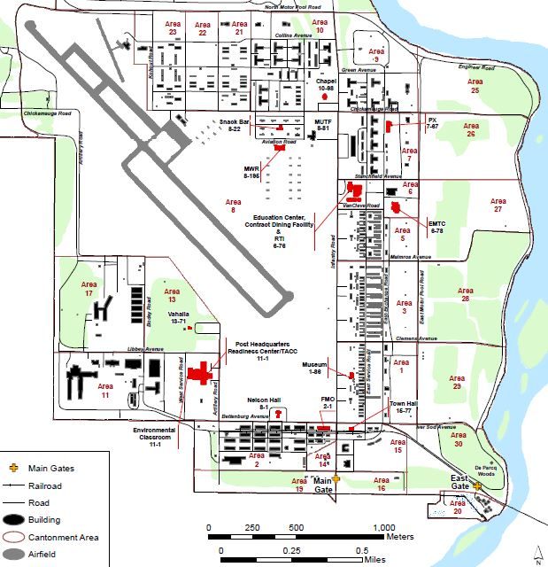

Emergency Phone Numbers
Emergency Medical, Please DO NOT use 911!
- Headquarters Building 3-1 call: 320-616-7221
- A staffed 24-hour First Aid in Building 3-1 call: 320-616-7222
- Camp Ripley Camping Area Emergency: 320-632-7375
- Camp Ripley Range Emergency: 320-616-3137
Program Refund Policy
FOR ALL PROGRAM ACTIVITIES including Summer Camp
Effective January 1st, 2022

A great deal of advance planning and advance purchasing takes place for all programs and events of the Central Minnesota Council, during the months and weeks prior to an event, (facility rentals, supplies, staff hiring, food contracting, and program material acquisition.) Because of this CMC, BSA has had to renew its refund policy.
Program activity registration fees are transferable to another Scout, for the same event, at any time.
- Refunds requested up to two weeks (14 days) prior to an event may receive up to a 75% refund. Cancellations within 13 days of the event will not be refundable but can be transferred to another person. All refunds will be evaluated on a case-by-case basis.

- Types of refunds considered: serious illness or injury (doctors slip required) or death in immediate family. Refunds are not given for no-shows, conflict of schedule (such as sporting events), out of county trips, weather conditions, or behavior issues occurring before or during the event. Your request for a refund must be made in writing and received within 5 days of missed event.
- Refunds will be returned to the person(s) or entity from which the funds were received.

Refund requests should be sent to:
Central Minnesota Council, BSA- 1191 Scout Drive Sartell, MN 56377. Attention: Refund Requested
You may also e-mail your request to the staff advisor for that event (info found on the registration page) or the Council.
Please include: participants name, unit, number, district, address, contact phone number, name, and date of event.

