2024 Popcorn Sale
Central Minnesota Council, Boy Scouts of America

Fund your entire Scout program year!

2024 Popcorn Briefing for Kernels

- Sunday, July 28th at 1pm - CMC Boy Scout Office, 1191 Scout Dr, Sartell
- Sunday, July 28th at 5:30pm – Parker Scout Camp, Dining Hall, 21930 Paradise Dr. Nisswa

The 2024 Kernel must attend to receive full Commission

Training will help kernels learn about:

- Ideas for Show and Sell….Plus Take Orders to reach sales goals
- New products
- Online products and how to set the Scouts online account up
- How to earn additional commissions for the unit
- Learn about new prizes for Scouts
- Find out more about additional individual and unit incentives

2024 Popcorn Briefing for Kernels
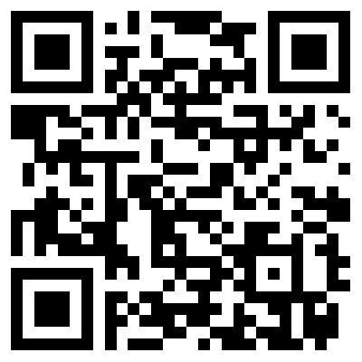
Register online with QR Code or
Return this form before July 24th to
sheri@bsacmc.org, or by mail/drop off:
Central Minnesota Council, BSA
1191 Scout Drive, Sartell, MN 56377

Kernel Name _________________

Unit Type Choose an item. Unit Number _________________

Email Address _________________________________________________

Address _______________________________________________________

Home Phone _________________________ Cell Phone _________________________

Which briefing session location are you attending? (Choose one)

☐ Sartell ☐ Parker Scout Camp

