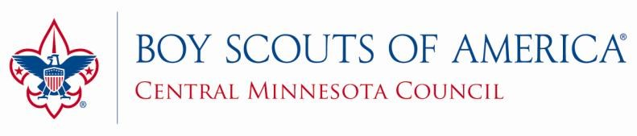

100% Trained Scout Leader Recognition Form

The following is required to qualify for the Central Minnesota Council, BSA.
Trained Scout Leader Award
Type of Training Date Completed
Youth Protection Training _______________________________________________________________
Before the first Meeting _______________________________________________________________
First 30 Days _________________________________________________________________________
Position Specific _______________________________________________________________
Intro to Outdoor Leader Skills (Asst. SM/ SM only) ______________________________________
(If you can attach a copy of the Training Card you received or the Certificate you printed if the training was done online, that would be very helpful but is not required)
Name of Applicant
Pack/Troop Number
Phone Number
E-Mail
Current Position ____ __________________________________________________
District Approval
Return this form to your District Executive or drop by the Central MN Council, BSA office.

